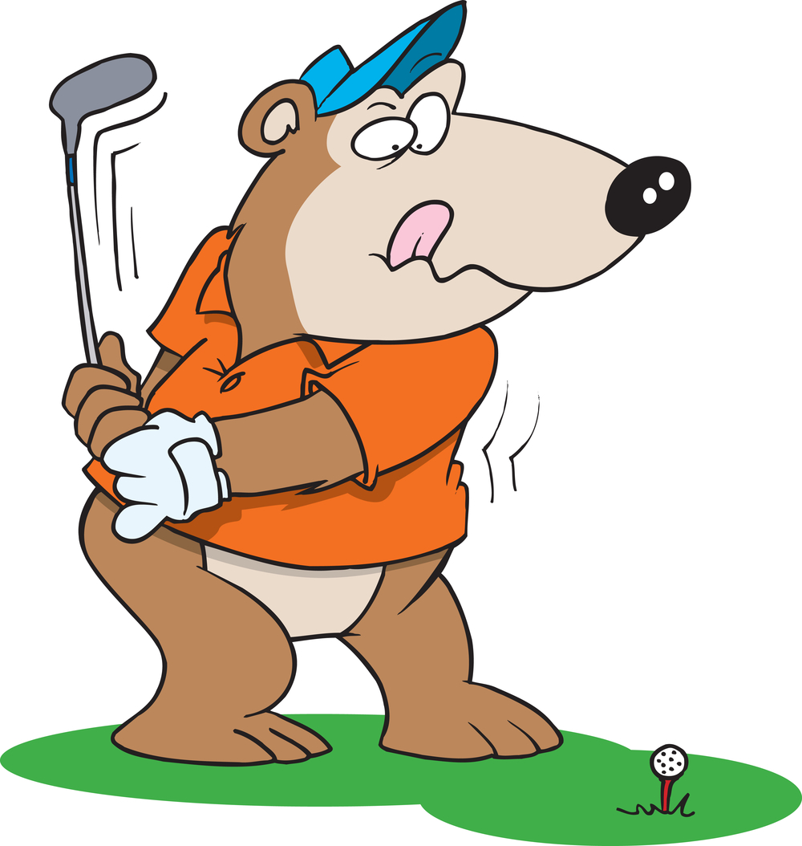
California High School
CHS

C

CAL

2nd Annual

Alumni Golf Tournament
Saturday, October 24, 2015
San Ramon Golf Club

4 Person Scramble

Shot-Gun Start 12noon

Any proceeds from this event will go to the California High School Alumni Association

Grizzly Sponsor $2500
Company Name/Logo display and sponsor recognition on all promotional and advertising materials.
Company Name/Logo on tournament banner
Table-top signage with give away items (to be provided by sponsor) at registration table
Company Name/Logo on Grizzly Snack bags for all players

Orange & Black Sponsor $1500
Company Name/Logo display and sponsor recognition on all promotional and advertising materials.
Company Name/Logo on tournament banner
??

Sponsor $1000
Company Name/Logo display and sponsor recognition on all promotional and advertising materials.
Company Name/Logo on tournament banner
??

Longest Drive Sponsor $150
Company Name/Logo display and sponsor recognition on all promotional and advertising materials
Company Name/Logo on tournament banner
Company Name/Logo on signage at designated hole
Company/Name/Logo on Longest Drive award/trophy

Closest to Pin Sponsor $150
Company Name/Logo display and sponsor recognition on all promotional and advertising materials
Company Name/Logo on tournament banner
Company Name/Logo on signage at designated hole
Company/Name/Logo on Closest to Pin award/trophy

“Boobie” Trap Sponsor $150
Company Name/Logo display and sponsor recognition on all promotional and advertising materials
Company Name/Logo on tournament banner
Company Name/Logo on signage at designated hole
Company/Name/Logo on Boobie Trap award/trophy

* All sponsors are encouraged to contribute items for the golfers “Goodie Bags”!
Such as, promotional items, gift certificates or discount coupons, brochures, business cards, etc.

